Introduction of Database Base Management System:

Database
A database is an organized collection of related information about particular subjects or purpose. i.e The collection of data usually referred to as database. So it is called computer based record keeping system or store-house of information. For example phone directory is an example of database consisting name ,address etc of people.
Similarly for example: A university database consisting information about student,courses,grade with having different record and it is also combination of different related files.
i.e student:F1
Name | Address | class
Course:F2
Course_Name | Course_no | Department

Grade: F3
Name | grade
fig: A university Database
Database management system(DBMS):

Database management system(DBMS) is a collection of interrelated data and a set of programs that enables user to create and maintain a database.Thus DBMS is a general purpose software system that facilitates the process of defining, constructing, manipulating and sharing of database among various users and applications.
Defining: This process involves specifying the basic data types, structure and constraints for the data to be stored in the database.
Constructing: This process involves the process of data storage in some storage medium which is controlled by DBMS.
Manipulating: This process includes such function such as querying the database to retrieve specific data, updating the database and generating reports from the database.
Sharing: This process allows multiple user and programs to access the database concurrently.
Hence DBMS is a software system that provides a environment to create database and controls the overall operations inside the database.
The following are the some examples of database management system:Ms-Access,oracle,My SQL,MS SQL etc.
Thus the overall computerize record keeping system is called a Database system:
i.e Database+DBMS software=Database System
Why a database?
Traditional file system have been used from the beginning for managing data in a computer.In traditional file system ,the data can be duplicate ,they cant be shared and security and integrity problem.It was very difficult to search data.So it is not easy to work with in a file system where every things kept in a file.After the advent of database all those problems have been over come.
The advantages of data base over traditional file system:
- Removes data redundancy problem: The repetition of the same data items in more than one file is known as data redundancy i.e. duplicated data. Such duplication waste file space.In file processing system data are duplicated in many places. For example: If the bank uses the file-oriented method to store customer data and maintain separate files for its various types of service such as saving account, term deposit and loan account. In this case data item of bank costumer(such as home address, age , occupation) may be contained in all the files thus repetition of customer identification in different services which leads cost of data entry and storage. so if we represent all details of customer are stored in a single file which is represented by a cide number ,then Repetition can be minimized. Thus redundancy of data can easily minimized using database.
2.Removes inconsistency problem:In file processing method, the updation made in one file is not reflected into the other related files. Thus information does not remain consistent automatically when editing data in one files.Suppose when we pay bill it is stored in the bill file not updated automatically in the receipt file. Every things is to be done manually. Database does not allow to ne inconsistent and maintain consistency as it automatically update the other related files simultaneously.
3.Sharing of data: In file processing data can not be shared.if some body is using one file ,others ca not share that file.But in database system ,data can be shared.many users can share same data at he same time.
4.Improves security:The data in file is not very secureT
Database VS File System:
The file oriented approach is the traditional method used in early days of data processing and has largely replaced today by database-orientated approach. However, several applications dealing with simple and small data sets ,still uses the file-oriented approach even today.In file oriented approach a set of programs is provided to facilitate the users in organizing,creating,deleting,updating and manipulating their files.
for example: In bank the system programmers have to write following program files to perform operation.
-A program to debit or credit an account.
-A program to add a new account
-A program to find balance of account
Thus as the time goes the system requires more files and application programs.

1.1 Purposes of Database System:
The primary goal of DBMS is to provide a user with an environment that is both convenient and efficient for retrieving and storing database information. Similarly the purpose of database system is to record and maintain information required for organization for decision making. Database are designed to handle large bodies of information and management of data involves both defining structure for storage of information and providing mechanism for manipulating it over long period of time.
Thus database system is designed to overcome following problem in traditional file system:(Advantages and Benefits of using DBMS)

- Controlling Redundancy and inconsistency problem
- The repetition of same information in database is called redundancy of data which leads several problems such as wastage of space. In file processing system the same data are repeated in many files. For example suppose we want to keep records of student studying, we will have to maintain three files: the first for registration, second for monthly bills, third for receipt information. Here details of students ,name, age ,sex, etc appear in all three files, which shows the redundancy of data. This repetition of data can be minimize by using database system where if the details of each student are stored in a file which is represented by a code number, then repetition can be minimize as the two other files can only use the code instead of all the details design.
In file processing system, the updating made in one file is not reflect into the other related files. Thus the information does not remain consistent automatically while editing data in one file. Thus DBMS does not allow database to be consistent and maintain consistency as it automatically updates the related files simultaneously.
2) Difficulty to accessing data: Need to write a new program to carry out each new task which may create difficulties to write new program to performing and accessing those data.
3) Integrity problem: An integrity constraint is a type of restriction that is involved. So in traditional file system, the validity of data can not be checked. Any data may be added to the file. there is no any restriction of any data at the time of entry in the file. But in database integrity can be enforced. For example: the name field which consists alphabet does not accept any number. Similarly the balance of a bank account may never fall below (say$25).
4) Concurrent access: concurrent access means access to the same data simultaneously by more than one user. This facility can not be enforced in traditional file system. For example now a days job websites are available The details of jobs are stored in database and many users can browse the site and access the information about vacancies simultaneously. Thus database supports concurrent access to the database.
5) Security problems: The data in file is not secure. The files can be protected with password if someone knows password she/he can access to the entire data in file. But in database data can be made more secure by applying different level of security.

Advantages of DBMS: Disadvantages:

a)Controlling Redundancy -initial investment is high for implementing DBMS.
b) Restricting Unauthorized access. -proper training is needed to the staff
c) Enforcing Integrity Constraints.
d) Easy in accessing Data.
e) Concurrent access to database.
f)providing Backup of data.

DBMS Languages:
- DDL - Data Definition Language is used to define both schemas.
- VDL - View Definition Language is used to specify the mapping of the user views to the conceptual schema.
- DML - Data Manipulation Language is used to provide a means to manipulate the database. (I.e. insert, delete, query,etc)
Database Applications:
Banking: for customer information, accounts, and loans, and banking transaction.
Airlines: for reservations, schedules information
Universities: for student information, course registrations, grades
Sales: for customers, products and purchases information
Manufacturing: production, inventory, orders, supply chain
Human resources: for information about employees records, salaries, tax.
Data Models:
A data model is a collection of conceptual tools for describing data ,data relationships, data semantics ,data consistency constraints. Data model is also a logical structure of data elements which describe the design of a database at the logical level.

1.Relational data model
The model which uses a collection of tables to represent both data and relationships among those data is called relational data model. Each table consists of set of rows and set of columns each column has a unique name called attributes.Each rows are called tuples. A row in a table represents a relationship among set of values.Since a table is a collection of such relationships,there is a close correspondence between the concept of table and mathematical concept of relation from which the relation data model takes its name.

The relational model is today the primary data model for commercial data processing applications. The relational model is a record-based model. Record-based model are so named because the database is structured in fixed –format of records of several types. Each table contains records of a particular type.
Thus relational data model is most widely used data model and a vast majority of current database system based on the relational model. The relational model is at a lower level of abstraction than E-R model. so database designer firstly carried out E-R model and then translated to the relational model.

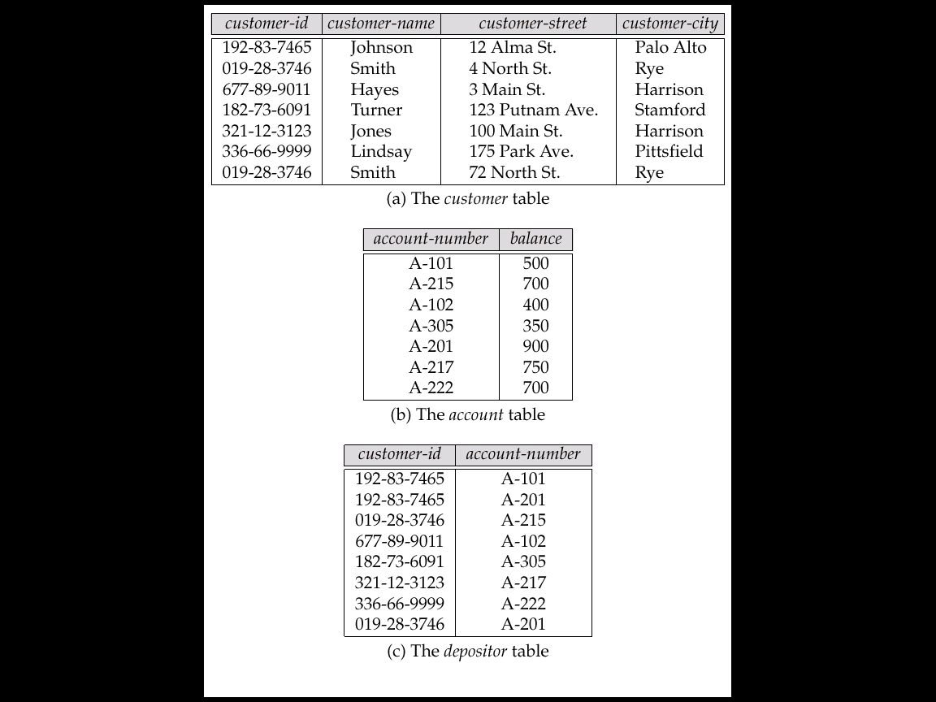

fig: A simple relational database.

- Hierarchical Model

The hierarchical data model organizes data in a tree structure. There is a hierarchy of parent and child data segments. Data in a series of records, which have a set of field values attached to it. These record types are the equivalent of tables in the relational model, and with the individual records being the equivalent of rows. To create links between these record types, the hierarchical model uses Parent Child Relationships.. For example, in fig below shows a hierarchical database of an organization’s employees.Each employees are categorized by the department in which they work,and within department ,they are categorized by their job function,such as managers,engineers,techinicians and support staff. In a hierarchical database the parent-child relationship is one to many. This restricts a child segment to having only one parent segment.
Organization
Technical
department
Finance
department
Personal
department
manager
manager
manager
Support
staff
Support
staff
engineer
Fig: Hierarchical database model
3) Network model:

A network database is an extension of the hierarchical database structure. in this model also the data elements of a database are organized in the form of parent-child relationships and all types of relationships among the data elements must be determined when the database first designed. in network model, howevere a child can have more than one parent element or no parent at all.
college

computer
math
english

jemes
Ram
shyam
gita

Fig:An example of a network database

4)Entity-Relationship Model
The entity-relationship(ER) data model represent the real world as consisting of basic objects, called entities, and relationship among these objects graphically, which also represent the logical structure of database. The ER model is a conceptual data model that views the real world as entities and relationships. A basic component of the model is the Entity-Relationship diagram which is used to visually represent data objects.
2.1 Basic concepts:
Entity:

An entity is “ a things” or object in the real world which is distinguishable from other objects. For example a person, account, a teacher, book, employee etc. An entity has set of properties which helps to identify each entity which are called attributes .e.g A employee entity has ,id, name, address, phone etc.
Entity set:-

The set of all entities of the same type that share the same properties or attributes aree called entity sets. e.g employee is an entity set which consisting entity type director ,manager ,coordinator ,clerk, teacher etc. similarly the set of all persons who are customer at a given bank can be defined as an entity set customer.
Attributes:
- An entity is defined by a set of properties which helps to uniquely identify each entity is called attributes. each entity attributes consisting individual values to identify each entity for example A employee entity has following attributes:-emp_id,name, address, age etc with emp_id=”11234”
Relationship

The association between several entities is called relationship which is also called interaction between entities.

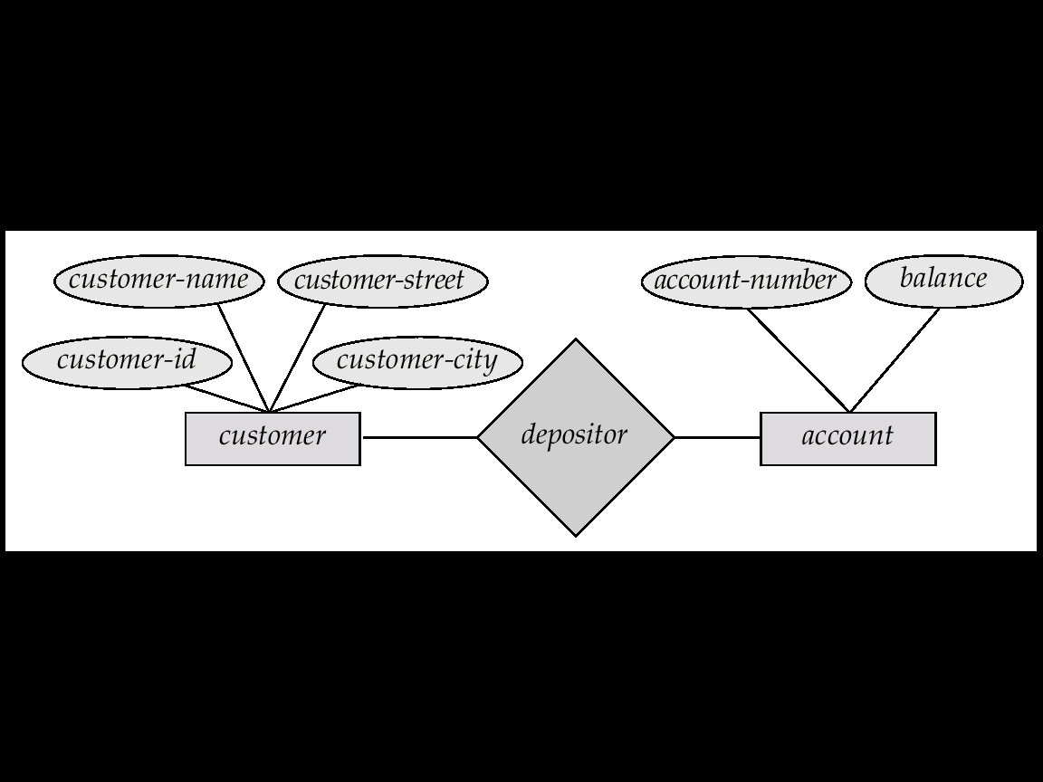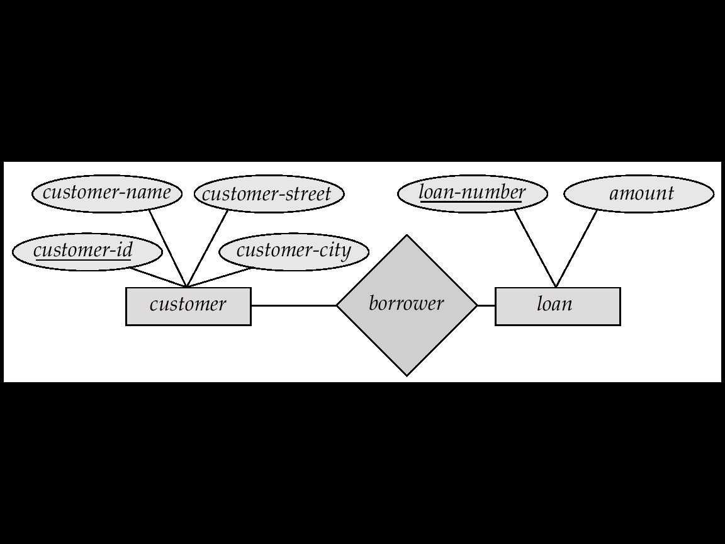
Fig2: A sample E-R Diagram of Bank

Primary keys(unique key):

Fig: Database system structure
A primary key is a candidate key (there may be more than one) chosen by the database designer to identify entities in an entity set. A Depending on its design, a table may have arbitrarily many unique keys but at most one primary key.
primary key is a value that can be used to identify a unique row in a table. Attributes are associated with it. Examples of primary keys are Social Security numbers (associated to a specific person) or ISBNs (associated to a specific book).
foreign key(Reference key): - A foreign key (FK) is a field or group of fields in a database record that points to a key field or group of fields forming a key of another database record in some (usually different) table. Usually a foreign key in one table refers to the primary key (PK) of another table. This way references can be made to link information together and it is an essential part of database normalization.
for example: -in employee relation, the DNO refers to the department for which an employee works ,which refer to DNUMBER of department relation and shows employees working in department.

Components of a database includes
User: - Users are the one who really uses the database. Users can be administrator, developer or the end users.
Data or Database: - As we discussed already, data is one of the important factor of database. A very huge amount of data will be stored in the database and it forms the main source for all other components to interact with each other. There are two types of data. One is user data. It contains the data which is responsible for the database, i.e.; based on the requirement, the data will be stored in the various tables of the database in the form of rows and columns. Another data is Metadata. It is known as ‘data about data’, i.e.; it stores the information like how many tables, their names, how many columns and their names, primary keys, foreign keys etc. basically these metadata will have information about each tables and their constraints in the database.
DBMS: - This is the software helps the user to interact with the database. It allows the users to insert, delete, update or retrieve the data. All these operations are handled by query languages like MySQL, Oracle etc.
Database Application: - It the application program which helps the users to interact with the database by means of query languages. Database application will not have any idea about the underlying DBMS.
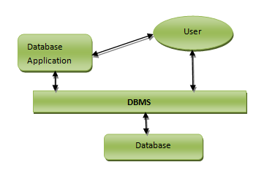
Database architecture:
Database architecture can be 2-tier or 3 tier architecture based on how users are connected to the database to get their request done. They can either directly connect to the database or their request is received by intermediary layer, which synthesizes the request and then it sends to database.
- Centralized DBMS:
  - Combines everything into single system including- DBMS software, hardware, application programs, and user interface processing software.
User can still connect through a remote terminal – however, all processing is done at centralized site.
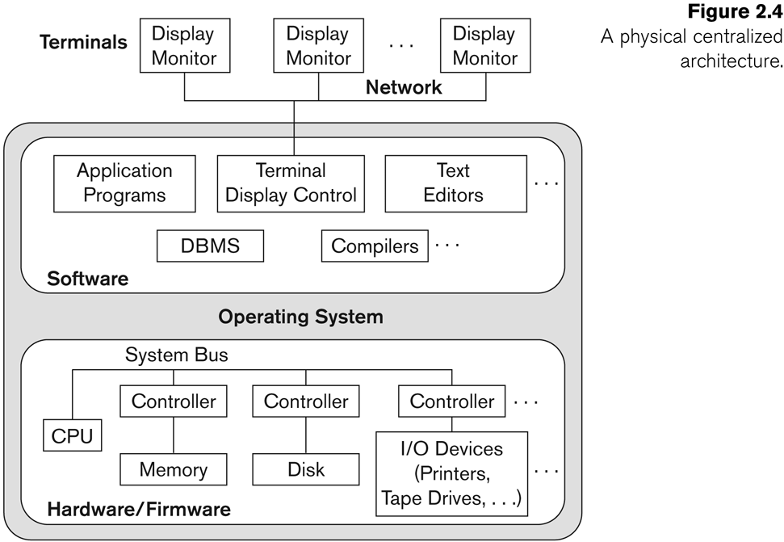

2-tier Architecture
In 2-tier architecture, application program directly interacts with the database. There will not be any user interface or the user involved with database interaction. Imagine a front end application of School, where we need to display the reports of all the students who are opted for different subjects. In this case, the application will directly interact with the database and retreive all required data. Here no inputs from the user are required. This involves 2-tier architecture of the database.
Let us consider another example of two tier architecture. Consider a railway ticket reservation system. How does this work? Imagine a person is reserving the ticket from Delhi to Goa on particular day. At the same time another person in some other place of Delhi is also reserving the ticket to Goa on the same day for the same train. Now there is a requirement for two tickets, but for different persons. What will reservation system do? It takes the request from both of them, and queues the requests entered by each of them. Here the request entered to application layer and request is sent to database layer. Once the request is processed in database, the result is sent back to application layer for the user.
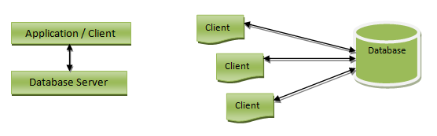

Advantages of 2-tier Architecture
- Easy to understand as it directly communicates with the database.
- Requested data can be retrieved very quickly, when there is less number of users.
- Easy to modify – any changes required, directly requests can be sent to database
- Easy to maintain – When there are multiple requests, it will be handled in a queue and there will not be any chaos.

Disadvantages of 2-tier architecture:
- It would be time consuming, when there is huge number of users. All the requests will be queued and handed one after another. Hence it will not respond to multiple users at the same time.
- This architecture would little cost effective.

3-tier Architecture
3-tier architecture is the most widely used database architecture. It can be viewed as below.
- Presentation layer / User layer is the layer where user uses the database. He does not have any knowledge about underlying database. He simply interacts with the database as though he has all data in front of him. You can imagine this layer as a registration form where you will be inputting your details. Did you ever guessed, after pressing ‘submit’ button where the data goes? No right? You just know that your details are saved. This is the presentation layer where all the details from the user are taken, sent to the next layer for processing.
- Application layer is the underlying program which is responsible for saving the details that you have entered, and retrieving your details to show up in the page. This layer has all the business logics like validation, calculations and manipulations of data, and then sends the requests to database to get the actual data. If this layer sees that the request is invalid, it sends back the message to presentation layer. It will not hit the database layer at all.
- Data layer or Database layer is the layer where actual database resides. In this layer, all the tables, their mappings and the actual data present. When you save you details from the front end, it will be inserted into the respective tables in the database layer, by using the programs in the application layer. When you want to view your details in the web browser, a request is sent to database layer by application layer. The database layer fires queries and gets the data. These data are then transferred to the browser (presentation layer) by the programs in the application layer.
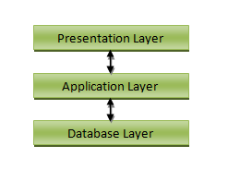

Advantages of 3-tier architecture:
- Easy to maintain and modify. Any changes requested will not affect any other data in the database. Application layer will do all the validations.
- Improved security. Since there is no direct access to the database, data security is increased. There is no fear of mishandling the data. Application layer filters out all the malicious actions.
- Good performance. Since this architecture cache the data once retrieved, there is no need to hit the database for each request. This reduces the time consumed for multiple requests and hence enables the system to respond at the same time.

Disadvantages 3-tier Architecture
Disadvantages of 3-tier architecture are that it is little more complex and little more effort is required in terms of hitting the database.

Database Administrators
The life cycle of database starts from designing, implementing to administration of it. A database for any kind of requirement needs to be designed perfectly so that it should work without any issues. Once all the design is complete, it needs to be installed. Once this step is complete, users start using the database. The database grows as the data grows in the database. When the database becomes huge, its performance comes down. Also accessing the data from the database becomes challenge. There will be unused memory in database, making the memory inevitably huge. These administration and maintenance of database is taken care by database Administrator – DBA.
A DBA has many responsibilities. A good performing database is in the hands of DBA.
- Installing and upgrading the DBMS Servers: - DBA is responsible for installing a new DBMS server for the new projects. He is also responsible for upgrading these servers as there are new versions comes in the market or requirement. If there is any failure in upgradation of the existing servers, he should be able revert the new changes back to the older version, thus maintaining the DBMS working. He is also responsible for updating the service packs/ hot fixes/ patches to the DBMS servers.
- Design and implementation: - Designing the database and implementing is also DBA’s responsibility. He should be able to decide proper memory management, file organizations, error handling, log maintenance etc for the database.
- Performance tuning: - Since database is huge and it will have lots of tables, data, constraints and indices, there will be variations in the performance from time to time. Also, because of some designing issues or data growth, the database will not work as expected. It is responsibility of the DBA to tune the database performance. He is responsible to make sure all the queries and programs works in fraction of seconds.
- Migrate database servers: - Sometimes, users using oracle would like to shift to SQL server or Netezza. It is the responsibility of DBA to make sure that migration happens without any failure, and there is no data loss.
- Backup and Recovery: - Proper backup and recovery programs needs to be developed by DBA and has to be maintained him. This is one of the main responsibilities of DBA. Data/objects should be backed up regularly so that if there is any crash, it should be recovered without much effort and data loss.
- Security: - DBA is responsible for creating various database users and roles, and giving them different levels of access rights.
- Documentation: - DBA should be properly documenting all his activities so that if he quits or any new DBA comes in, he should be able to understand the database without any effort. He should basically maintain all his installation, backup, recovery, security methods. He should keep various reports about database performance.
ANSI/SPARC architecture:-Three-Schema DBMS Architecture
American National standard Institute established a study group on DBMS for standard planning with the mission of feasibility study of setting up standards in this area.
- External level - This is the highest level in data abstraction. At this level users see the data in the form of rows and columns. This level illustrates the users how the data is stored in terms of tables and relations. Users view full or partial data based on the business requirement. The users will have different views here, based on their levels of access rights. For example, student will not have access to see Lecturers salary details, one employee will not have access to see other employees details, unless he is a manager. At this level, one can access the data from database and perform some calculations based on the data. For example calculate the tax from the salary of employee, calculate CGPA of a Student, Calculate age of a person from his Date of Birth etc. These users can be real users or any programs.
Any changes/ computations done at this level will not affect other levels of data. That means, if we retrieve the few columns of the STUDENT table, it will not change the whole table, or if we calculate the CGPA of a Student, it will not change/update the table. This level of data is based on the below levels, but it will not alter the data at below levels.
- Logical/ Conceptual level - This is the next level of abstraction. It describes the actual data stored in the database in the form of tables and relates them by means of mapping. This level will not have any information on what a user views at external level. This level will have all the data in the database.
Any changes done in this level will not affect the external or physical levels of data. That is any changes to the table structure or the relation will not modify the data that the user is viewing at the external view or the storage at the physical level. For example, suppose we have added a new column ‘skills’ which will not modify the external view data on which the user was viewing Ages of the students. Similarly, it will have space allocated for ‘Skills’ in the physical memory, but it will not modify the space or address of Date of Birth (using which Age will be derived) in the memory. Hence external and physical independence is achieved.
- Internal level - This is one of the intermediary levels. In most of the cases this level is not mentioned and usually it is said that we have 3 levels of data abstraction. This level depends on the DBMS software. This level is how the database is seen from DBMS. We can even combine logical level and this level.
- Physical level - This is the lowest level in data abstraction. This level describes how the data is actually stored in the physical memory like magnetic tapes, hard disks etc. In this level the file organization methods like hashing, sequential, B+ tree comes into picture. At this level, developer would know the requirement, size and accessing frequency of the records clearly. So designing this level will not be much complex for him.
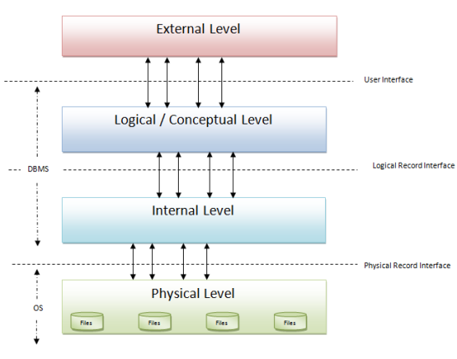
Data Mining:
- The discovery of new information in terms of patterns or rules from vast amounts of data.
- The process of finding interesting structure in data.
- The process of employing one or more computer learning techniques to automatically analyze and extract knowledge from data.

data mining (sometimes called data or knowledge discovery) is the process of analyzing data from different perspectives and summarizing it into useful information - information that can be used to increase revenue, cuts costs, or both. Data mining software is one of a number of analytical tools for analyzing data. It allows users to analyze data from many different dimensions or angles, categorize it, and summarize the relationships identified. Technically, data mining is the process of finding correlations or patterns among dozens of fields in large relational databases.
Applications:
- Marketing
  - Marketing strategies and consumer behavior
- Finance
  - Fraud detection, creditworthiness and investment analysis
- Manufacturing
  - Resource optimization
- Health
  - Image analysis, side effects of drug, and treatment effectiveness

Data Warehouses
Data warehousing is defined as a process of centralized data management and retrieval. Data warehousing, like data mining, is a relatively new term although the concept itself has been around for years. Data warehousing represents an ideal vision of maintaining a central repository of all organizational data.
“A data warehouse is simply a single, complete, and consistent store of data obtained from a variety of sources and made available to end users in a way they can understand and use it in a business context.”

Defn: collection of data designed to support management decision making. Data warehouses contain a wide variety of data that present a coherent picture of business conditions at a single point in time.
Development of a data warehouse includes development of systems to extract data from operating systems plus installation of a warehouse database system that provides managers flexible access to the data. The term data warehousing generally refers to the combination of many different databases across an entire enterprise.
Big Data:
Big data is data sets that are so voluminous and complex that traditional data processing application software are inadequate to deal with them. Big data challenges include capturing data, data storage, data analysis, search, sharing, transfer, visualization, querying, updating and information privacy. There are five dimensions to big data known as Volume, Variety, Velocity and the recently added Veracity and Value.
While the term “big data” is relatively new, the act of gathering and storing large amounts of information for eventual analysis is ages old. The concept gained momentum in the early 2000s.
Volume. Organizations collect data from a variety of sources, including business transactions, social media and information from sensor or machine-to-machine data. In the past, storing it would’ve been a problem – but new technologies (such as Hadoop) have eased the burden.
Velocity. Data streams in at an unprecedented speed and must be dealt with in a timely manner. sensors and smart metering are driving the need to deal with torrents of data in near-realtime.
Variety. Data comes in all types of formats – from structured, numeric data in traditional databases to unstructured text documents, email, video, audio, stock ticker data and financial transactions
Examples:
Eg: Google processes 20 PB a day (2008)
Wayback Machine has 3 PB + 100 TB/month (3/2009)
Facebook has 2.5 PB of user data + 15 TB/day (4/2009)
eBay has 6.5 PB of user data + 50 TB/day (5/2009
Lots of data is being collected
and warehoused
Web data, e-commerce
purchases at department/
grocery stores
Bank/Credit Card
transactions
Social Network
THE END

